Chapter 3: Methodology

3.1 Lifecycle Data Analysis
MovieMetrics is a dashboard that shows how movies perform at the box office and how much profit they make. It uses a dataset of 3,974 movies released between 1929 and 2016, which becomes 3,907 movies after data preparation (Section 3.7). This chapter explains how the business problem was defined and how the data was collected, understood, prepared and explored before the dashboard is built. The main tool is Microsoft Power BI. Power Query, which comes inside Power BI, is used to clean and change the data, while Power BI Desktop will be used to create the charts, the key performance indicator (KPI) cards, and the interactive pages of the dashboard.
The project follows the Cross-Industry Standard Process for Data Mining (CRISP-DM). This process starts with the business problem, moves to the data, and ends by sharing the results with the users. This project builds a dashboard with no prediction model, so the steps were changed a little. There are eight steps, and each step uses the output of the step before it. Figure 3.1 shows the flow from start to end.
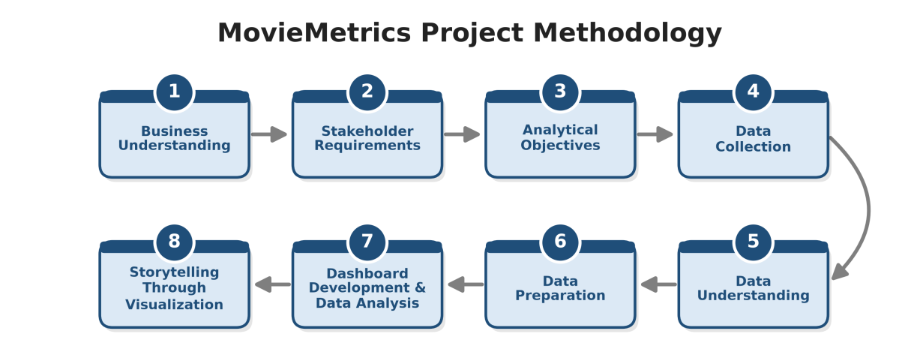
Figure 3.1: Methodology Flow of the MovieMetrics Project

3.2 Business Understanding
Producing a film requires a substantial amount of money, and having a high gross income at the box office does not guarantee that the film is profitable. Some movies generate tremendously high revenues but might end up suffering losses due to their very high production costs. Right now, participants in the industry do not know which genres yield the highest profits, which budget is safe and when a movie is more likely to incur losses.
Additionally, producers and marketers do not know whether films with high IMDb ratings or with many awards actually generate more profit or not. It is also hard for them to find out which actors and filmmakers have been able to bring money to the box office. Investors also need to see how budgets and box office revenues have changed in the course of time before investing their money in a new film project. The information they look for is found in the table containing data about films, but it is contained in a long table consisting of 16 columns which is too complicated to read.
If this problem continues, producers and investors will keep wasting money on new films without clear evidence or planning; some of these films may lose money. Therefore, analyzing the movie data through the MovieMetrics dashboard can help them see which types of movies made a profit in the past and make better decisions for the new films.

3.3 Stakeholder Requirements
The main users of the MovieMetrics dashboard are studio executives, producers, investors, directors, and marketing managers. Each group needs something different, but all of them want to use the data to lower the risk and make better choices when planning a movie.
When studio executives and investors see the dashboard for the first time, they need quick information about what is currently going on with box office takings. They want to know the total box office earnings, total earnings, median return on investment (ROI), and percentage of losses among films. They would also like to compare the genres of films so that they would at least have some idea which type of film could bring in more income. A good dashboard should also provide information to producers about the budget of a film, so it should produce information about the dependence of earnings from the budget and the frequency of money loss for each budget level.
At the same time, directors have to reconcile their creative ideas with actual budget limitations. They have to understand whether high IMDb ratings and a number of awards are linked to high financial performance. The dashboard should provide information for marketing managers about the ranking of directors and actors regarding the total box office returns and receipts of their films.
In addition to this, all users require an intuitive dashboard. They will look for a way to filter information by genre, release date, director and actor, and to access more information after clicking or hovering over the chart. The design must be simple, and the essential information must be placed at the top of each page.

3.4 Analytical Objectives
The analytical objectives turn the stakeholder requirements in Section 3.3 into specific questions that the MovieMetrics dashboard must answer. Each objective links to one of the five problem statements in Chapter 1 and names the measures and groups used to answer it, so the results can be checked against the cleaned dataset of 3,907 movies.
1. To compare total box office, total earnings, median return on investment (ROI) and loss rate across the 14 movie genres, in order to identify the most profitable genres and to check whether the genres that earn the most in total also give the best return per dollar spent.
2. To evaluate the loss rate and median ROI of films in three budget categories, Low (below $20 million), Medium ($20 million to $80 million) and High (above $80 million), in order to identify which budget level carries the lowest risk of financial loss.
3. To examine how films in three IMDb score levels, High (7.0 and above), Medium (5.0 to 6.9) and Low (below 5.0), and films with and without Oscar or Golden Globe wins differ in box office revenue, earnings and loss rate.
4. To rank the top 10 directors and the top 10 lead actors by total box office revenue and earnings, together with their Director Box Office % and Actors Box Office %, in order to identify the talent with a proven record of bringing audiences to the cinema.
5. To track the changes in median production budget, total box office revenue and median ROI by release year and decade from 1929 to 2016, in order to show investors how costs and returns in the film industry have changed over time.

3.5 Data Collection
This project uses secondary data. The dataset, Movies (IMDb, Earnings and more), was published on Kaggle by Delfina Oliva and last updated on 20 September 2024 (Oliva, 2024). The uploader compiled it from Wikipedia, IMDb and The Movie Database (TMDB). The team downloaded it as a single comma-separated values (CSV) file, movies_data.csv, from https://www.kaggle.com/datasets/delfinaoliva/movies. The team did not collect any primary data through surveys or interviews, and the dataset holds no personal or sensitive information, as it only describes publicly released films.
The raw file contains 3,974 movie records and 16 attributes, covering films released between 1929 and 2016 across 14 genres. The attributes include the movie title, director, three main actors, genre, running time, budget, box office revenue, earnings, the Actors Box Office % and Director Box Office %, the number of Oscar and Golden Globe nominations and awards, release year and IMDb score. According to the dataset description, Budget covers the money spent on making and publicising a film, Earnings is the difference between box office and budget, and the two Box Office % columns show how often the cast or the director at least doubled the budget in their other films. The file was imported directly into Microsoft Power BI Desktop through Get Data (Text/CSV) for cleaning in Power Query, as described in Section 3.7.

3.6 Data Understanding
Data Understanding is the process to examine the dataset to understand the information contained in it before carrying out further analysis. In this study, the dataset consists of movie-related information to analyze box office performance and profitability in the film industry. The dataset contains 16 attributes related to the movie industry which provide information about movies, directors, actors, genres, financial performance, awards, release year, and IMDb scores. It is important to understand the characteristics of the dataset to identify the variables that are relevant to the objectives of the MovieMetrics project. Therefore, the variables were examined based on their categories, data types, descriptions, and examples before proceeding to the data preparation stage.
Table 3.1: Categories of Variables
No. | Category | Description | Examples
1 | Movie Information | Variables that provide basic information about the movie and its production. | Movie, Director, Genre, Running time
2 | Cast Information | Variables that provide information about the main actors involved in the movie. | Actor 1, Actor 2, Actor 3
3 | Financial Performance | Variables related to the financial performance and revenue of the movie. | Budget, Box Office, Earnings
4 | Talent Contribution | Variables related to the contribution of actors and directors to box office performance. | Actors Box Office %, Director Box Office %
5 | Awards and Recognition | Variables that show the number of nominations and awards received by the movie. | Oscar and Golden Globes nominations, Oscar and Golden Globes awards
6 | Movie Rating and Release | Variables that provide information about the release period and audience rating of the movie. | Release year, IMDb score
The dataset contains both categorical and numerical variables. These data types help to identify suitable methods for analyzing the dataset.
Table 3.2: Summary of Data Types
Data Type | Variables | Description
Categorical (Nominal) | Movie, Director, Actor 1, Actor 2, Actor 3, Genre | Variables that contain names, titles or categories.
Numerical | Running time, Budget, Box Office, Actors Box Office %, Director Box Office %, Earnings, Release year, IMDb score | Variables that contain numerical values which can be used for calculation and analysis.
Numerical (Count) | Oscar and Golden Globes nominations, Oscar and Golden Globes awards | Variables representing the number of nominations or awards received.
Table 3.3 shows the data dictionary of the dataset, which provides a detailed description of each attribute, including its data type and examples. All examples come from the same film, Edge of Tomorrow (2014). This table helps give a clearer understanding of information contained in each variable and its purpose in the analysis.
Table 3.3: Data Dictionary
No. | Attribute | Data Type | Description | Example
1 | Movie | Categorical (Nominal) | The title of the movie. | Edge of Tomorrow
2 | Director | Categorical (Nominal) | The director of the movie. | Doug Liman
3 | Running time | Numerical (Integer) | The duration of the movie in minutes. | 113
4 | Actor 1 | Categorical (Nominal) | The first main actor listed in the dataset. | Tom Cruise
5 | Actor 2 | Categorical (Nominal) | The second main actor listed in the dataset. | Lara Pulver
6 | Actor 3 | Categorical (Nominal) | The third main actor listed in the dataset. | Noah Taylor
7 | Genre | Categorical (Nominal) | The genre or category of the movie. | Action
8 | Budget | Numerical | The money spent on making and publicising the movie. | 178000000
9 | Box Office | Numerical | The money the movie earned from ticket sales. | 370000000
10 | Actors Box Office % | Numerical | The percentage of the main actors' other films that earned at least double their budget. | 91.67
11 | Director Box Office % | Numerical | The percentage of the director's other films that earned at least double their budget. | 85.71
12 | Earnings | Numerical | The profit of the movie, calculated as Box Office minus Budget. | 192000000
13 | Oscar and Golden Globes nominations | Numerical (Count) | The number of Oscar and Golden Globes nominations received by the movie. | 0
14 | Oscar and Golden Globes awards | Numerical (Count) | The number of Oscar and Golden Globes awards received by the movie. | 0
15 | Release year | Numerical (Integer) | The year in which the movie was released. | 2014
16 | IMDb score | Numerical (Decimal) | The IMDb rating given to the movie by registered IMDb users, out of 10. | 7.9

3.7 Data Preparation
Data preparation turns the raw movies_data.csv file into a clean table for the MovieMetrics dashboard. The team carried out the cleaning in Power Query and created the derived variables with DAX in Power BI Desktop. The raw file holds 3,974 rows and 16 columns. After preparation, the final table holds 3,907 movies and 22 columns.

3.7.1 Data Import and Profiling
The team imported movies_data.csv through Get Data (Text/CSV) and set File Origin to 1252: Western European (Windows). The file uses this encoding, and the default UTF-8 setting garbles 311 cells that contain accented characters, such as "Amélie" and "Brüno". The team then turned on Column Quality, Column Distribution and Column Profile and set profiling to the entire dataset, so the checks covered all 3,974 rows instead of the first 1,000.

3.7.2 Data Type Correction
The team set Movie, Director, Actor 1, Actor 2, Actor 3 and Genre to Text. Budget, Box Office and Earnings became Fixed Decimal Number for currency formatting. Running time, Release year and the two award columns became Whole Number. IMDb score, Actors Box Office % and Director Box Office % became Decimal Number.

3.7.3 Missing Value Check
Table 3.4 shows the result of the missing value check on the raw dataset.
Table 3.4: Missing Value Check (n = 3,974)
No. | Attribute | Missing (count) | Missing (%) | Action
1 | Movie | 0 | 0.00 | None
2 | Director | 0 | 0.00 | None
3 | Running time | 0 | 0.00 | None
4 | Actor 1 | 0 | 0.00 | None
5 | Actor 2 | 0 | 0.00 | None
6 | Actor 3 | 2 | 0.05 | Replace with "Unknown"
7 | Genre | 0 | 0.00 | None
8 | Budget | 0 | 0.00 | None
9 | Box Office | 0 | 0.00 | None
10 | Actors Box Office % | 0 | 0.00 | None
11 | Director Box Office % | 0 | 0.00 | None
12 | Earnings | 0 | 0.00 | None
13 | Oscar and Golden Globes nominations | 0 | 0.00 | None
14 | Oscar and Golden Globes awards | 3 | 0.08 | Replace with 0
15 | Release year | 0 | 0.00 | None
16 | IMDb score | 0 | 0.00 | None
 | Total | 5 | 0.01
The dataset contains 5 missing cells out of 63,584, so it needed no large-scale imputation. The two films with no Actor 3, Fantasia and Gerry, list two lead performers, so "Unknown" keeps their financial data in the totals. The three films with a blank award count, Billy Elliot, Drive and Beyond the Sea, received nominations but no Oscar or Golden Globe wins, so 0 gives the correct value. The check also found no zero or negative values in Budget, Box Office, Running time or IMDb score.

3.7.4 Text Cleaning
The team applied Trim and Clean to every text column. This step fixed 9 actor names with leading or trailing spaces (2 in Actor 1, 1 in Actor 2 and 6 in Actor 3). Without the fix, each of these actors would be counted as two different people.

3.7.5 Duplicate Removal
The duplicate check found two kinds of repeated records:
- Exact duplicates: 24 rows matched another row in every column, for example Bad Moms (2016) and Dredd (2012). The team removed them with Remove Duplicates on all columns.
- Conflicting duplicates: 43 more rows repeated the same Movie, Release year and Director but carried different financial figures. For example, Alice in Wonderland (2010) appears with a box office of both $1.02 billion and $334 million. The lower figure matches the film's domestic gross, while the higher figure matches its worldwide gross. The team sorted Box Office from largest to smallest and kept the first row for each Movie, Release year and Director combination, which keeps the worldwide figure. Where two rows also shared the same box office figure, as with Spider-Man 3 (2007) and Ghostbusters (2016), the team added Oscar and Golden Globe awards and then nominations as second and third sort keys, so the kept row does not depend on the order of rows in the file.
Together, these steps removed 67 rows and reduced the dataset from 3,974 to 3,907 movies.

3.7.6 Invalid Values and Validation
Two films carried impossible values in Actors Box Office %: Safe (6.8 trillion %) and Code Name: The Cleaner (5.1 trillion %). A percentage cannot exceed 100, so the team replaced these two values with blanks.
The team also checked three rules across the whole dataset:
- Earnings = Box Office − Budget: the rule held for all 3,974 rows, with 0 mismatches.
- Release year: every value falls between 1929 and 2016.
- IMDb score: every value falls between 1.6 and 9.3, inside the 1 to 10 scale.
Three films list more awards than nominations, such as Star Wars: Episode VI with 4 nominations and 6 awards. Special achievement awards need no nomination, so the team kept these values.

3.7.7 Formulas for Derived Variables
Table 3.5 lists the DAX formulas the team used for the derived columns and summary measures. Two hidden helper columns, Budget Order and IMDb Order, hold the numbers 1 to 3 so that Low, Medium and High always sort in that order; users never see them.
Table 3.5: Formulas Used in Data Preparation
Variable | Type | DAX Formula | Purpose
ROI (%) | Calculated column | ROI = DIVIDE(movies_data[Earnings], movies_data[Budget]) * 100 | Return per dollar spent
Profit Status | Calculated column | Profit Status = IF(movies_data[Earnings] > 0, "Profit", IF(movies_data[Earnings] < 0, "Loss", "Break-even")) | Label each film's outcome
Budget Category | Calculated column | Budget Category = SWITCH(TRUE(), movies_data[Budget] < 20000000, "Low", movies_data[Budget] <= 80000000, "Medium", "High") | Group films by budget level
Decade | Calculated column | Decade = FLOOR(movies_data[Release year], 10) & "s" | Group years into periods
Award Status | Calculated column | Award Status = IF(movies_data[Oscar and Golden Globes awards] > 0, "Award winner", "No award") | Compare award winners with other films
Total Box Office | Measure | Total Box Office = SUM(movies_data[Box Office]) | Summary measure
Total Earnings | Measure | Total Earnings = SUM(movies_data[Earnings]) | Summary measure
Median ROI | Measure | Median ROI = MEDIAN(movies_data[ROI]) | Summary measure
Loss % | Measure | Loss % = DIVIDE(CALCULATE(COUNTROWS(movies_data), movies_data[Profit Status] = "Loss"), COUNTROWS(movies_data)) | Share of films that lost money
Profit Status uses three labels because 66 films earned the same amount as their budget, which makes them neither a profit nor a loss.
The team uses median ROI instead of average ROI as the summary measure of return. Paranormal Activity cost $15,000 and earned $193 million at the box office, an ROI of 1,286,567%. This single film pushes the average ROI to 866.8%, while the median ROI stands at 110.0%. The median reflects what a typical film returns, so it gives investors a fairer picture.

3.7.8 IMDb Score Categorisation
The team grouped IMDb score into three levels so that films can be grouped by rating level:
IMDb Category = SWITCH(TRUE(), movies_data[IMDb score] >= 7, "High", movies_data[IMDb score] >= 5, "Medium", "Low")
A score of 7.0 and above counts as High, 5.0 to 6.9 as Medium, and below 5.0 as Low. These levels let users compare the ROI and box office of well-rated films against poorly rated ones, which answers the third analytical objective in Section 3.4 about whether high ratings bring higher profit.

3.7.9 Data Balance Check
The team checked how evenly the 3,907 movies spread across the main grouping variables. Table 3.6 shows the results.
Table 3.6: Data Balance Check (n = 3,907)
Variable | Group | Count | Percentage
Profit Status | Profit | 2,858 | 73.2%
 | Loss | 983 | 25.2%
 | Break-even | 66 | 1.7%
IMDb Category | High (≥ 7.0) | 1,358 | 34.8%
 | Medium (5.0 to 6.9) | 2,227 | 57.0%
 | Low (< 5.0) | 322 | 8.2%
Budget Category | Low (< $20M) | 1,749 | 44.8%
 | Medium ($20M to $80M) | 1,740 | 44.5%
 | High (> $80M) | 418 | 10.7%
Genre | Comedy | 1,002 | 25.6%
 | Action | 942 | 24.1%
 | Drama | 594 | 15.2%
 | Crime | 261 | 6.7%
 | Adventure | 235 | 6.0%
 | Biography | 230 | 5.9%
 | Horror | 218 | 5.6%
 | Animation | 177 | 4.5%
 | Thriller | 100 | 2.6%
 | Sci-Fi | 67 | 1.7%
 | Documentary | 46 | 1.2%
 | Mystery | 20 | 0.5%
 | Western | 11 | 0.3%
 | Romance | 4 | 0.1%
The results show that the dataset is imbalanced. Profitable films outnumber loss-making films by almost three to one (73.2% against 25.2%). Genre shows the strongest imbalance: Comedy and Action together hold 49.7% of the films, while Mystery, Western and Romance together hold 0.9%. Release years also lean toward recent films, with 70.7% of the movies released between 2000 and 2016.
This project does not build a prediction model, so the team did not resample the data. Oversampling or undersampling would change the real totals that stakeholders rely on. Instead, the imbalance will be taken into account in the later analysis: genres will be compared using median ROI and Loss % instead of raw totals, so a genre with more films does not look stronger because of its size alone. Genres and decades with fewer than 25 films, such as Mystery, Western and Romance, will be left out of ROI rankings in the later analysis, because a handful of films can swing their results.

3.7.10 Outlier Treatment
Extreme values such as Avatar at $2.9 billion box office and Paranormal Activity at a 1,286,567% ROI reflect real results, not entry errors, so the team kept them. Using median ROI in place of average ROI stops these films from distorting the summary figures.
Table 3.7: Summary of Data Preparation Steps
No. | Step | Action | Result
1 | Import and profile | File Origin 1252; Column Quality, Distribution, Profile | 3,974 rows, 16 columns loaded
2 | Fix data types | Text, Whole Number, Decimal, Fixed Decimal | Correct sums and sorting
3 | Missing value check | Actor 3 → "Unknown"; awards → 0 | 5 cells filled
4 | Clean text | Trim and Clean | 9 names fixed
5 | Remove duplicates | Exact and conflicting duplicates | 67 rows removed
6 | Fix invalid values | Actors Box Office % above 100 → blank | 2 values fixed
7 | Validate | Earnings formula, year and score ranges | 0 errors
8 | Derive variables | ROI, Profit Status, Budget Category, IMDb Category, Decade, Award Status | 6 columns added
9 | Balance check | Count per group | Imbalanced; handled in design
10 | Load and model | Close & Apply; DAX measures | 3,907 rows, 22 columns

3.8 Exploratory Data Analysis (EDA)
Exploratory Data Analysis (EDA) gives a first, general understanding of the 3,907 movies left after data preparation. It uses summary statistics and simple charts to show the minimum, maximum and typical values of each variable and how the films are spread. At this stage the section only describes the data: it does not compare groups, test relationships between variables or make assumptions about what makes a film profitable. Those questions are answered later, in Chapter 5. Table 3.8 summarises the numerical variables.
Table 3.8: Summary Statistics of Numerical Variables (n = 3,907)
Variable | Minimum | Maximum | Median | Mean
Budget | $1,100 | $390.0M | $22.0M | $36.2M
Box Office | $50,000 | $2,923.0M | $42.2M | $106.8M
Earnings | -$323.1M | $2,686.0M | $18.0M | $70.6M
Running time (minutes) | 20 | 330 | 105 | 109.9
IMDb score | 1.6 | 9.3 | 6.6 | 6.47
Release year | 1929 | 2016 | 2004 | 2002
Actors Box Office % | 0.00 | 100.00 | 57.14 | 56.16
Director Box Office % | 0.00 | 100.00 | 50.00 | 52.63
Oscar and Golden Globes nominations | 0 | 22 | 0 | 1.11
Oscar and Golden Globes awards | 0 | 13 | 0 | 0.32

Observation 1: Overall Dataset (Summary Cards)
The cleaned dataset holds 3,907 movies released between 1929 and 2016. Together they cost $141.4 billion to make and took $417.3 billion at the box office, giving total earnings of $276.0 billion. The median film returned 110.0% of its budget, and 983 films (25.2%) lost money.
So what: the total box office is almost three times the total budget, and about one film in four lost money.
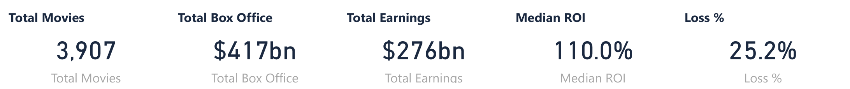
Figure 3.2: Summary Cards for the Cleaned Dataset

Observation 2: Number of Films by Genre (Bar Chart)
The movies fall into 14 genres. Comedy is the largest genre with 1,002 films (25.6%), followed by Action with 942 and Drama with 594. Romance is the smallest with 4 films, after Western with 11 and Mystery with 20.
So what: the genres are uneven in size: three genres hold 65.0% of the films, while Mystery, Western and Romance together hold 0.9%.
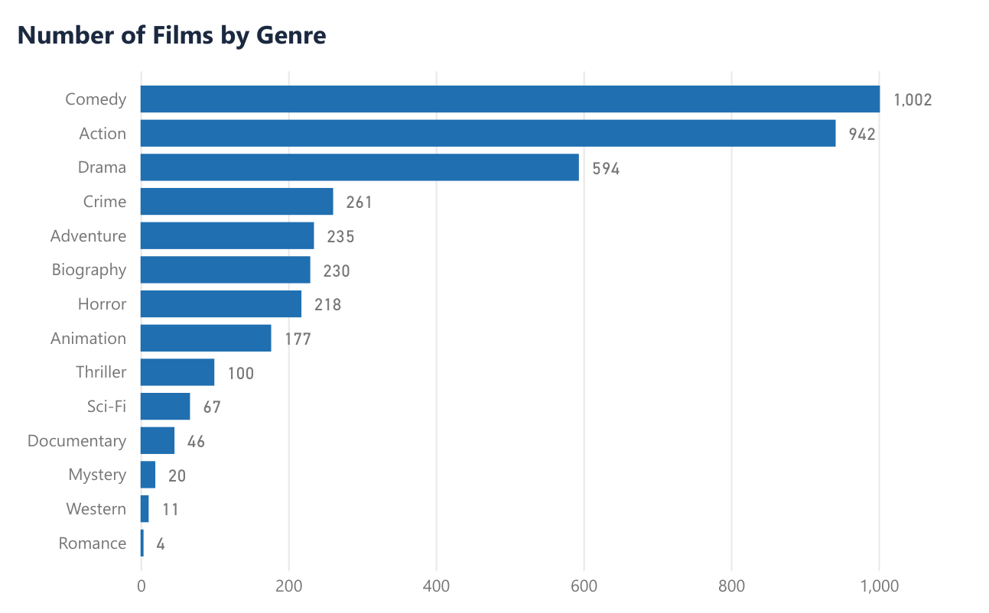
Figure 3.3: Number of Films by Genre

Observation 3: Number of Films by Decade (Column Chart)
Release years run from 1929 to 2016, with a median of 2004. The number of films grows in almost every decade, from 1 film in the 1920s to 1,682 in the 2000s, the busiest decade. The 2010s hold 1,081 films even though they only cover 2010 to 2016. 70.7% of the films were released from 2000 onwards, while 202 films come from before 1980.
So what: the dataset mostly describes recent films; the decades before 1970 together contain only 109 films (2.8%).
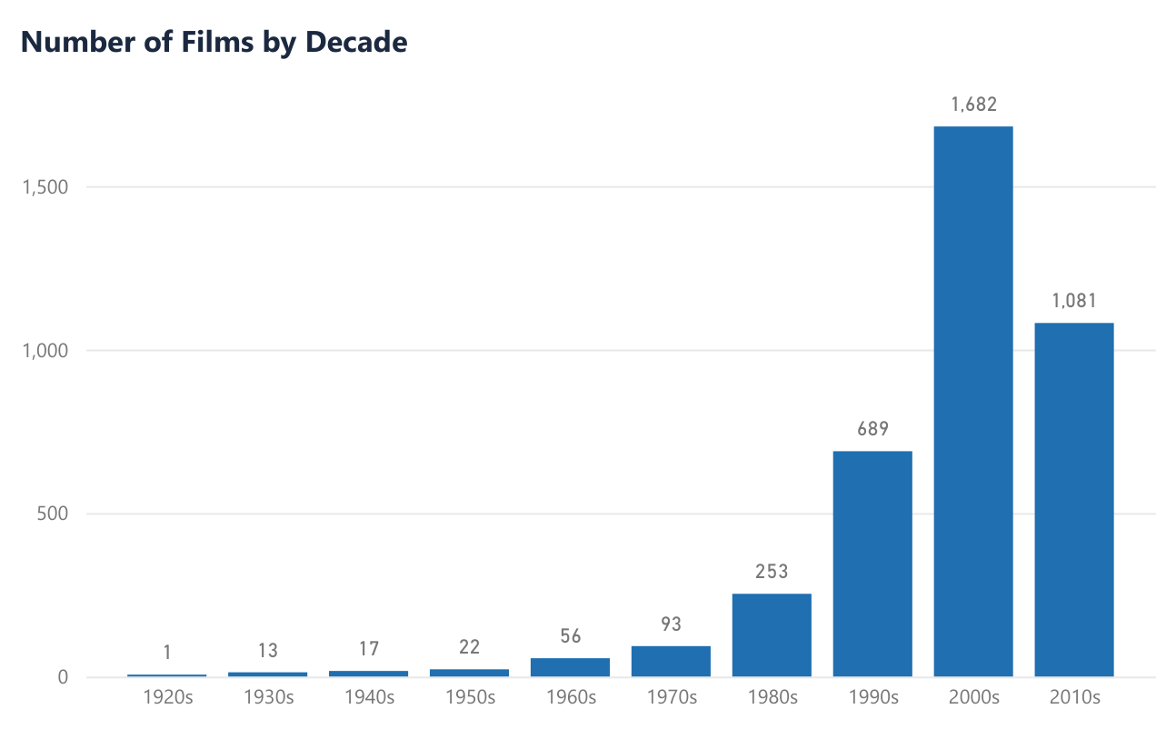
Figure 3.4: Number of Films by Decade

Observation 4: Budget Distribution (Histogram)
Budgets range from $1,100 (My Date with Drew, 2004) to $390 million (The Messenger: The Story of Joan of Arc, 1999), with a median of $22.0 million and a mean of $36.2 million. 1,749 films (44.8%) cost less than $20 million, and only 2 films cost $300 million or more.
So what: the distribution is strongly right-skewed: the mean ($36.2 million) is well above the median ($22.0 million) because a small number of films have very large budgets.
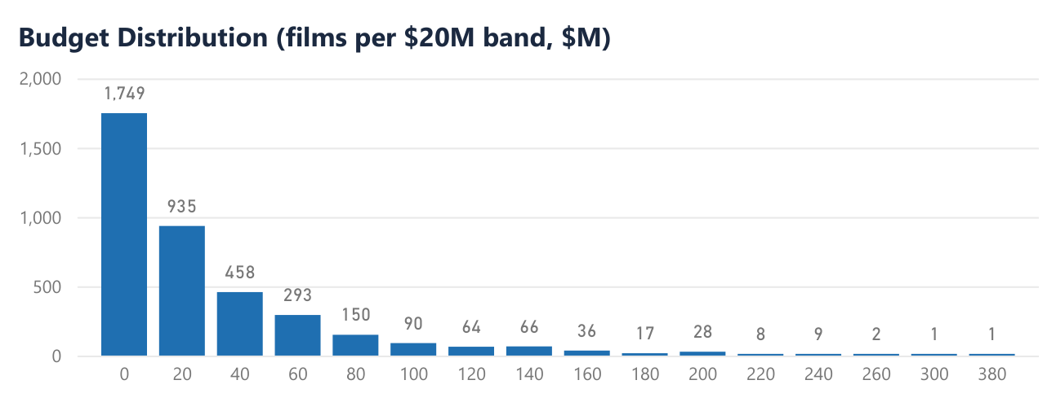
Figure 3.5: Budget Distribution

Observation 5: Box Office Distribution (Histogram)
Box office revenue ranges from $50,000 (Ask Me Anything, 2014) to $2.92 billion (Avatar, 2009), with a median of $42.2 million and a mean of $106.8 million. 2,733 films (70.0%) earned less than $100 million, and 24 films earned $1 billion or more.
So what: box office is even more right-skewed than budget: the top 10% of films (390 films) earned 49.5% of all box office revenue.
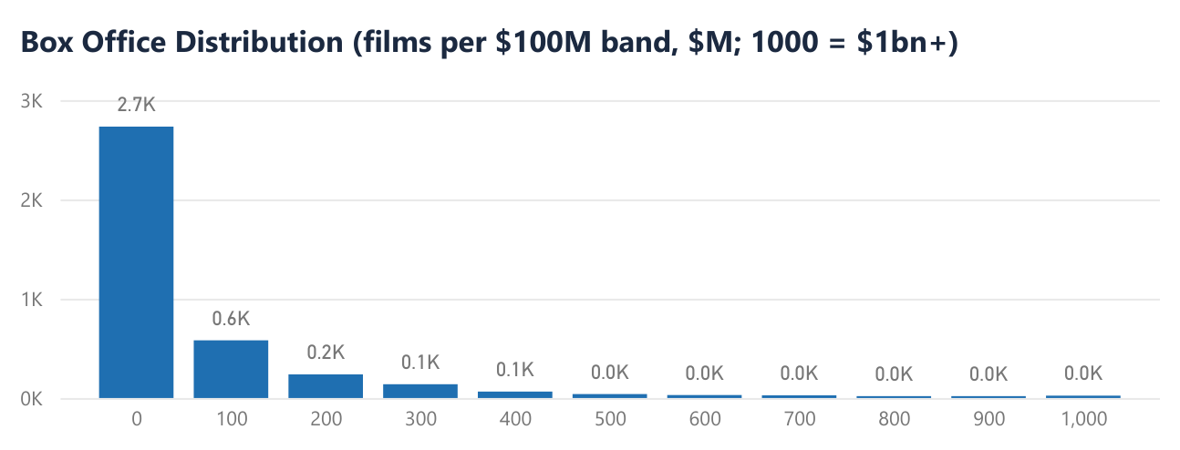
Figure 3.6: Box Office Distribution

Observation 6: Films by Profit Status (Donut Chart)
Earnings range from a loss of $323.1 million (The Messenger: The Story of Joan of Arc, 1999) to a profit of $2.69 billion (Avatar, 2009), with a median of $18.0 million. 2,858 films (73.2%) made a profit, 983 films (25.2%) made a loss and 66 films (1.7%) earned exactly their budget back.
So what: most films in the dataset made a profit, about one film in four made a loss, and break-even films are rare.
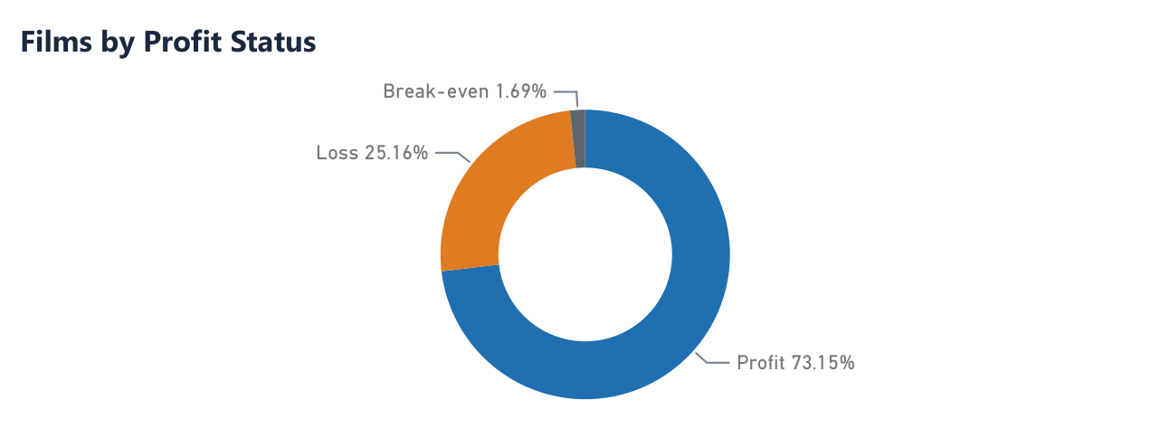
Figure 3.7: Films by Profit Status

Observation 7: IMDb Score Distribution (Histogram)
IMDb scores range from 1.6 (Justin Bieber: Never Say Never, 2011) to 9.3 (The Shawshank Redemption, 1994), with a median of 6.6 and a mean of 6.47. The most common band is 6.5 to 6.9, with 780 films, and 54.7% of the films score between 6.0 and 7.4. Only 322 films (8.2%) score below 5.0, and 244 films score 8.0 or higher.
So what: scores are slightly left-skewed: 85.5% of the films score between 5.0 and 7.9, and very low scores are rare.
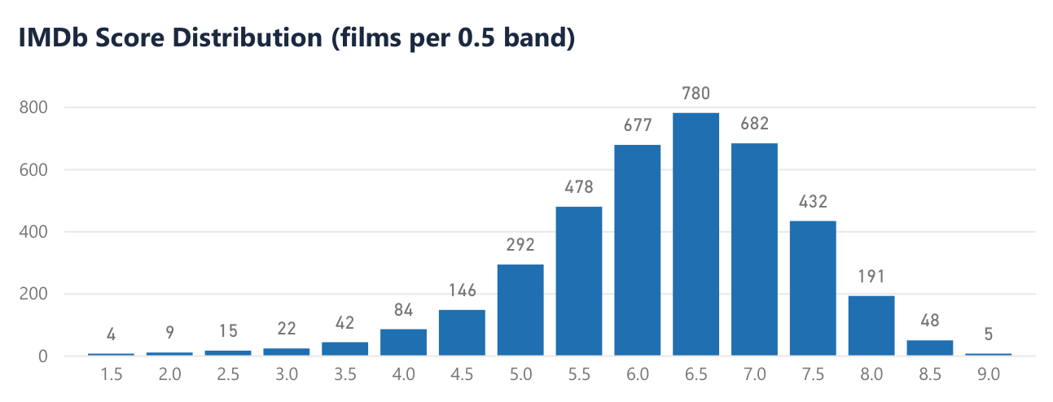
Figure 3.8: IMDb Score Distribution

Observation 8: Running Time Distribution (Histogram)
Running times range from 20 minutes (Wal-Mart: The High Cost of Low Price, 2005) to 330 minutes (Blood In Blood Out, 1993), with a median of 105 minutes and a mean of 109.9 minutes. 63.0% of the films run between 90 and 119 minutes, and 53 films run longer than three hours.
So what: running times cluster around 90 to 119 minutes; only 6 films run under an hour and 53 run over three hours.
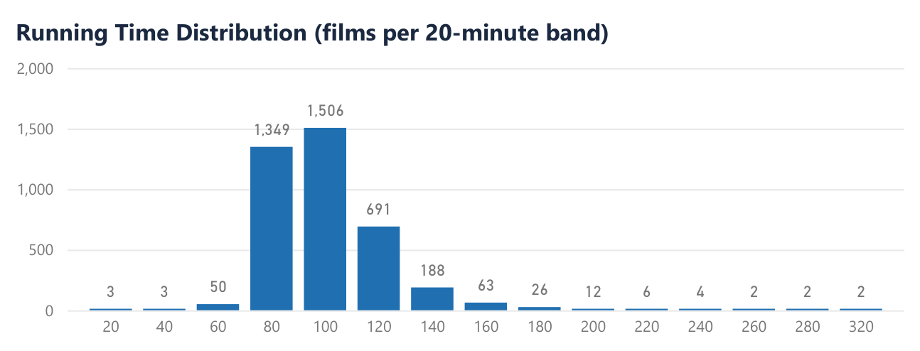
Figure 3.9: Running Time Distribution

Observation 9: Oscar and Golden Globe Nominations (Column Chart)
Nominations range from 0 to 22, and awards from 0 to 13. 2,793 films (71.5%) received no Oscar or Golden Globe nomination and 447 received one. Amadeus (1984) and Mary Poppins (1964) hold the most nominations, with 22 each. 458 films (11.7%) won at least one award.
So what: most films have zero in both award columns: 2,793 films (71.5%) have no nomination and 3,449 films (88.3%) have no award.
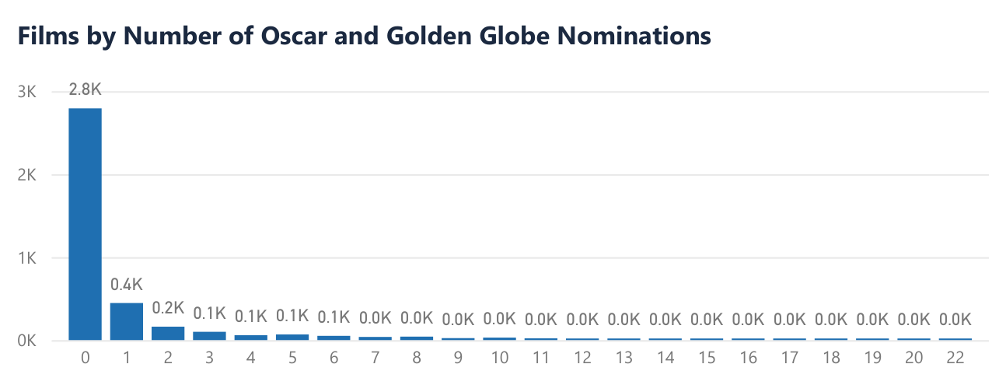
Figure 3.10: Films by Number of Oscar and Golden Globe Nominations

3.9 Features Overview
The analysis uses 22 features: the 16 original attributes and the six variables the team derived in Sections 3.7.7 and 3.7.8. Table 3.9 lists each feature and the role it plays in the analysis.
Table 3.9: Feature Overview
No. | Attribute | Category | Source | Role in the Analysis
1 | Movie | Categorical (Nominal) | Original | Identifies each film.
2 | Director | Categorical (Nominal) | Original | Used to rank directors by box office and earnings, and to filter by director.
3 | Running time | Numerical (Integer) | Original | Shows whether film length relates to box office and earnings.
4 | Actor 1 | Categorical (Nominal) | Original | Used to rank lead actors by box office, and to filter by actor.
5 | Actor 2 | Categorical (Nominal) | Original | Adds the second lead to cast analysis.
6 | Actor 3 | Categorical (Nominal) | Original | Adds the supporting cast to cast analysis.
7 | Genre | Categorical (Nominal) | Original | Used to compare box office, ROI and loss rate across genres, and to filter by genre.
8 | Budget | Numerical (Currency) | Original | Measures production cost; base for ROI and Budget Category.
9 | Box Office | Numerical (Currency) | Original | Measures ticket revenue; summed for total box office.
10 | Actors Box Office % | Numerical (Decimal) | Original | Gives the cast's box office track record score from the source dataset.
11 | Director Box Office % | Numerical (Decimal) | Original | Gives the director's box office track record score from the source dataset.
12 | Earnings | Numerical (Currency) | Original | Measures profit as Box Office minus Budget; summed for total earnings.
13 | Oscar and Golden Globes nominations | Numerical (Count) | Original | Counts nominations to measure critical recognition.
14 | Oscar and Golden Globes awards | Numerical (Count) | Original | Counts wins to compare award winners with other films.
15 | Release year | Numerical (Integer) | Original | Tracks budget and box office trends over time; base for Decade.
16 | IMDb score | Numerical (Decimal) | Original | Measures audience rating; base for IMDb Category.
17 | ROI (%) | Numerical (Decimal) | Derived | Measures return per dollar spent; summarised as median ROI.
18 | Profit Status | Categorical (Nominal) | Derived | Labels films as Profit, Loss or Break-even; used to calculate Loss %.
19 | Budget Category | Categorical (Ordinal) | Derived | Groups films into Low, Medium and High budgets for risk comparison.
20 | IMDb Category | Categorical (Ordinal) | Derived | Groups ratings into High, Medium and Low.
21 | Decade | Categorical (Ordinal) | Derived | Groups release years into decades to show change over time.
22 | Award Status | Categorical (Nominal) | Derived | Splits films into award winners and films with no award.
Chapter 4 explains how these features are turned into the dashboard design, and Chapter 5 uses the dashboard to answer the five analytical objectives in Section 3.4.

